**Ecommerce project setup Guidance**

* Install next js (<https://nextjs.org/docs/api-reference/create-next-app> please use this reference.)
  + npx create-next-app@latest –js **(PS F:\React projects\ecommerce>)**
* Modify dependencies inside package.json file.

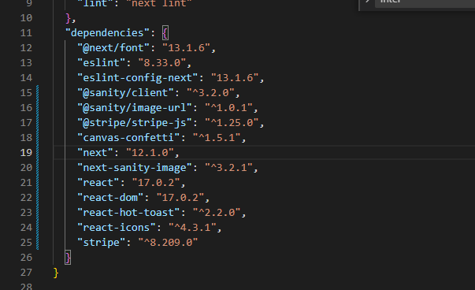

* Install dependencies using the following command.
  + npm install --legacy-peer-deps
* Run project
  + npm run dev
* Install sanity (<https://www.sanity.io/javascriptmastery> please use this reference.)
  + npm create sanity@latest -- --coupon javascriptmastery2022

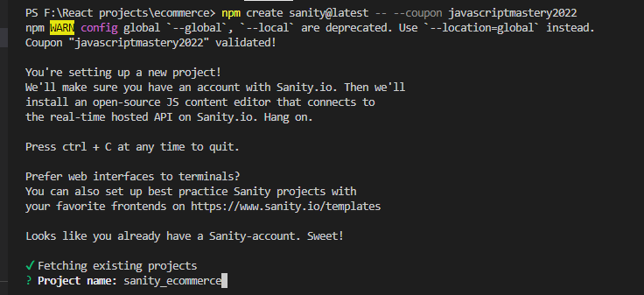

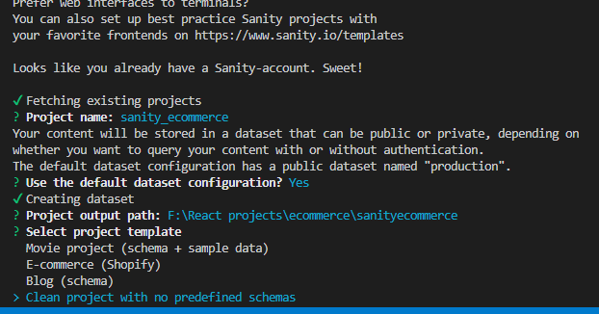

* Please select the above option and then press enter.
* To check sanity installed on your system please use following commands.
  + sanity docs
  + sanity manage
  + sanity start